
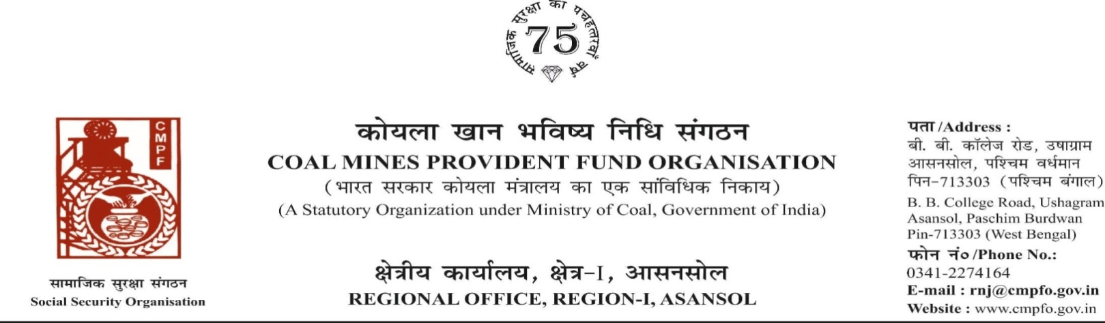
CPF/118/Misc/Ext-out/R-I/ASN/ Dated-15/07/2025

To,
The Regional Commissioner
Coal Mines Provident Fund
Police Line
Dhanbad , D-I
Dhanbad (jharkhand)
PIN-826014

Sub- Supply of Extract of "VV" statement

Ref:-CPF/JHA-25/A.K.MEHTA/D-1/63/393 Dated-09/07/2025

Sir,

On the subject and reference cited above,enclosed please find herewith the extract in r/o-
Sri Ajai Kumar Mehta CMPF A/C No- JHA/19/456 as required. Ledger Card is not available in this region.

Encl- As above

Yours faithfully

Assistant Commissioner

